SENTIMENT ANALYSIS OF TWEETS
Classifying Public Opinion on Trending Topics Using NLP and Machine Learning
A Project Report Submitted in the partial fulfillment of the requirements for the award of the degree of
BACHELOR OF TECHNOLOGY
In
DEPARTMENT OF COMPUTER SCIENCE AND ENGINEERING
By
V. Preetham Nikhil | : 2420030302
K. Rishikesh Reddy | : 2420030318
M. Sriram Madhav | : 2420030273
Under the Esteemed Guidance of
Dr. N. Sunanda
Assistant Professor
Department of Computer Science and Engineering
Course: Data Science (24AD3107) | Batch No: [Batch No.]
AY – 2026-2027
Semester: V


K L (Deemed to be) University
DEPARTMENT OF COMPUTER SCIENCE AND ENGINEERING
Declaration
The Project Report entitled “SENTIMENT ANALYSIS OF TWEETS” is a record of Bonafide work of V. Preetham Nikhil – 2420030302, K. Rishikesh Reddy – 2420030318, M. Sriram Madhav – 2420030273 submitted in partial fulfillment for the award of B.Tech in Computer Science and Engineering to the K L (Deemed to be) University. The results embodied in this report have not been copied from any other departments/University/Institute.
V. Preetham Nikhil – 2420030302
K. Rishikesh Reddy – 2420030318
M. Sriram Madhav – 2420030273
K L (Deemed to be) University
DEPARTMENT OF COMPUTER SCIENCE AND ENGINEERING
CERTIFICATE
This is to certify that the project based report entitled “SENTIMENT ANALYSIS OF TWEETS” is a bonafide work done and submitted by V. Preetham Nikhil – 2420030302, K. Rishikesh Reddy – 2420030318, M. Sriram Madhav – 2420030273 in partial fulfillment of the requirements for the award of the degree of BACHELOR OF TECHNOLOGY in Department of Computer Science and Engineering, K L (Deemed to be University), during the academic year 2026-2027.
Signature of the Guide | Signature of the Course Coordinator | Signature of the HOD

ACKNOWLEDGEMENT
The success of this project would not have been possible without the timely help and guidance rendered by many people. We wish to express our sincere thanks to all those who assisted us in one way or the other in the completion of our project.
Our greatest appreciation goes to our Course Coordinator [Name of Course Coordinator] and our guide Dr. N. Sunanda, Assistant Professor, Department of Computer Science and Engineering, whose tremendous support, encouragement and guidance cannot be expressed in words.
We express our gratitude to [Name of HOD], Head of the Department of Computer Science and Engineering, for providing us with adequate facilities, ways and means by which we were able to complete this project.
We thank all the members of the teaching and non-teaching staff, and all those who have assisted us directly or indirectly in the successful completion of this project. Finally, we sincerely thank our parents, friends and classmates for their kind help and cooperation during our work.

V. Preetham Nikhil – 2420030302
K. Rishikesh Reddy – 2420030318
M. Sriram Madhav – 2420030273

ABSTRACT
In the current era of digital communication, social media platforms such as Twitter (X) have become one of the most influential sources of real-time public opinion. Millions of users express their thoughts, emotions and reactions on political events, product launches, sports, entertainment and social issues, generating an enormous and continuously growing volume of unstructured textual data. Manually analysing this data is impractical because of its scale and the speed at which new content appears. This project presents a sentiment-analysis system that collects tweets related to a chosen trending topic and classifies them into positive, negative or neutral categories using Natural Language Processing (NLP) and machine-learning techniques.
The system collects tweets through the Twitter (X) API or from a suitable pre-existing dataset, focusing on a specific topic, hashtag or keyword. Because raw tweets are noisy and unstructured, an extensive preprocessing pipeline is applied: tokenisation, conversion to lower case, removal of stop words, stemming and lemmatisation, and careful handling of hashtags, user mentions, emojis, special characters and embedded URLs. The cleaned text is then converted into features using Bag-of-Words and Term Frequency–Inverse Document Frequency (TF-IDF).
Sentiment classification is performed with Naive Bayes, Support Vector Machine (SVM) and Logistic Regression, which are compared on identical data splits to identify the most suitable model; deep-learning architectures such as LSTM and transformer-based models like BERT are identified as extensions. Each model’s performance is evaluated using accuracy, precision, recall, F1-score and the confusion matrix. The classified sentiments are visualised through pie charts, bar graphs, sentiment trend lines over time and word clouds for each sentiment category, and an interactive Streamlit dashboard also predicts the sentiment of any typed tweet.
Overall, the project demonstrates how NLP and machine learning can extract meaningful, actionable insight from large volumes of unstructured social-media data. By combining data collection, text preprocessing, feature engineering, model training and result visualisation into one end-to-end pipeline, it supports applications such as brand monitoring and reputation management, political sentiment and election analysis, market research, customer-feedback analysis, and crisis or disaster response, where understanding public mood in real time supports faster and better-informed decisions.
Keywords: sentiment analysis, Twitter, natural language processing, text preprocessing, TF-IDF, Naive Bayes, SVM, Logistic Regression, data visualisation.

INDEX
S.No. | Chapters | Topics | Page no.
 |  | Acknowledgement | i
 |  | Abstract | ii
 |  | Index, List of Figures, List of Tables | iii
1 | Introduction | 1.1 Background of the project  1.2 Problem statement  1.3 Scope of the project  1.4 Objectives  1.5 Importance of the application  1.6 Target users / audience  1.7 Literature survey  1.8 Research gap and proposed solution | 1-4
2 | System Requirements | 2.1 Hardware requirements  2.2 Software requirements  2.3 Development tools and frameworks  2.4 Functional and non-functional requirements | 5-6
3 | Technology Stack | 3.1 Front-end (Streamlit, Plotly)  3.2 Back-end (Python, Pandas, NLTK, Scikit-learn)  3.3 Data storage  3.4 Version control (Git, GitHub)  3.5 APIs or external services | 7-8
4 | System Architecture | 4.1 High-level architecture diagram  4.2 Description of each layer  4.3 Deployment architecture  4.4 Data flow diagrams | 9-11
5 | Design | 5.1 Wireframes or mock-ups  5.2 ER diagram / database schema  5.3 Pipeline flowchart | 12-15
6 | Implementation | 6.1 Module-wise implementation  6.2 Data collection and preprocessing  6.3 EDA and feature extraction  6.4 Model building and evaluation  6.5 Visualisation and dashboard logic  6.6 Data connectivity and API integration  6.7 Access control and data privacy | 16-20
7 | Features | 7.1 List of main features  7.2 How each feature works (user perspective + technical description) | 21
8 | Testing | 8.1 Functional testing  8.2 Integration testing  8.3 Tools used for testing  8.4 Test cases and results  8.5 Validation method and evaluation framework  8.6 Results and performance comparison | 22-24
9 | Deployment | 9.1 Steps to deploy  9.2 Environment configuration  9.3 Hosting | 25
10 | Challenges & Limitations | 10.1 Issues faced during development  10.2 Solutions applied  10.3 Current limitations or known bugs | 26
11 | Future Enhancements | 11.1 Planned features  11.2 Possible integrations or optimisations  11.3 Real-world applications | 27
12 | Conclusion | 12.1 Summary of the project  12.2 What was achieved  12.3 Skills learned during development | 28
13 | References | Books, journals, tutorials, APIs and documentation sites used | 29
14 | Appendices | Screenshots of the application  Sample code snippets  Installation / set-up instructions  User manual or guide  Certifications  Team contribution | 30-31

LIST OF FIGURES
No. | Caption | Page
1.1 | The sentiment-analysis lifecycle followed in this project | 1
4.1 | High-level architecture of the sentiment-analysis system | 9
4.2 | DFD Level-0 (context diagram) | 10
4.3 | DFD Level-1 | 11
5.1 | Wireframe – Sentiment Overview | 12
5.2 | Wireframe – Live Tweet Predictor | 13
5.3 | Wireframe – Model Performance | 13
5.4 | Logical database schema (ER diagram) | 14
5.5 | Flowchart of the preprocessing and modelling pipeline | 15
8.1 | Layout of the confusion matrix used for evaluation | 23

LIST OF TABLES
No. | Caption | Page
1.1 | Scope of the project | 2
1.2 | Target users of the system | 3
1.3 | Summary of literature survey | 3
1.4 | Research gap and how this project addresses it | 4
2.1 | Hardware requirements | 5
2.2 | Software requirements | 5
3.1 | Technology stack at a glance | 8
4.1 | Deployment configuration | 10
5.1 | Description of schema entities | 14
6.1 | Modules of the system | 16
6.2 | Candidate data sources | 16
6.3 | Summary of the selected dataset | 16
6.4 | Algorithms used in the project | 18
7.1 | Feature descriptions – user perspective and technical description | 21
8.1 | Test cases | 22
8.2 | Evaluation metrics | 23
8.3 | Performance comparison of the models | 23
9.1 | Environment configuration | 25
10.1 | Challenges and solutions | 26
11.1 | Planned enhancements | 27
12.1 | Objectives and outcomes | 28
F.1 | Contribution of each team member | 31

CHAPTER 1
Introduction

1.1 Background of the Project
Social media platforms have changed the way people express opinions. Twitter (now X) is one of the most influential of them: millions of users post short messages every day about political events, product launches, sports, entertainment and social issues. Each post is small, but taken together they form a continuous, real-time record of public opinion and public mood. Organisations, governments and researchers increasingly want to know not only what is being said about a topic, but how people feel about it.
Sentiment analysis, also called opinion mining, is the branch of Natural Language Processing (NLP) that identifies the emotional polarity of a piece of text, usually as positive, negative or neutral. Doing this by hand for tweets is impractical because of the scale of the data and the speed at which new content appears. An automated system is therefore needed that can collect tweets on a topic, clean them, convert them into numerical form and classify them reliably.
Tweets are also a difficult kind of text. They are short, informal and noisy; they contain hashtags, user mentions, emojis, embedded URLs, abbreviations, slang and spelling variations. These features carry meaning, but they can also confuse a classifier if they are not handled carefully. This project builds a complete sentiment-analysis system for tweets that takes care of every stage, from collection to visualisation.
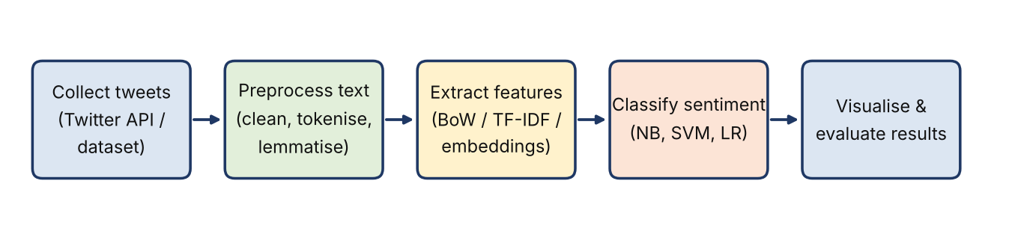
Fig. 1.1 The sentiment-analysis lifecycle followed in this project
As shown in Fig. 1.1, the lifecycle begins with the collection of tweets on a chosen trending topic, followed by text preprocessing, feature extraction, sentiment classification using machine-learning models, and finally the visualisation and evaluation of the results.

1.2 Problem Statement
Public opinion on social media is produced in huge volumes and in an unstructured form. As a consequence:
- The sheer volume and speed of tweets make manual reading and summarisation impractical.
- Raw tweets are noisy and unstructured, full of hashtags, mentions, emojis, URLs and informal spelling, which interfere with accurate sentiment detection if they are not managed properly.
- Organisations often learn about a shift in public mood late, after a brand, policy or event has already been affected.
- Students and analysts lack a simple, reproducible workflow that links data collection, text preprocessing, feature extraction, model comparison and visualisation in one place.
The problem addressed by this project is therefore to design and implement an end-to-end sentiment-analysis system that collects tweets related to a trending topic, cleans and converts them into features, classifies each tweet as positive, negative or neutral using NLP and machine-learning techniques, compares several models, and presents the results through clear visualisations.

1.3 Scope of the Project
The scope has been defined so that the work is achievable within the course duration while still demonstrating the complete pipeline.
Table 1.1 Scope of the project
In scope | Out of scope
Tweets on a chosen topic, hashtag or keyword, collected through the Twitter (X) API or taken from a suitable pre-existing dataset | Collection of private or protected accounts’ data
Full text-preprocessing pipeline for tweets (tokenisation, normalisation, stop-word removal, stemming and lemmatisation, handling of hashtags, mentions, emojis and URLs) | Sarcasm and irony detection as a separate task
Feature extraction using Bag-of-Words and TF-IDF | Training large deep-learning models (LSTM, BERT) – listed as future work
Three-class classification (positive, negative, neutral) using Naive Bayes, SVM and Logistic Regression | Multilingual and code-mixed tweets
Visualisation: pie chart, bar graph, sentiment trend line and word clouds; evaluation with accuracy, precision, recall and F1-score | Fully automated, continuous live streaming in production

The sentiment labels produced by the system describe the mood of a collection of tweets. They are not a judgement about any individual user and should be read together with the model’s accuracy figures.

1.4 Objectives
The objectives of the project are stated below. Each begins with an action verb and can be verified against the delivered system; the extent to which each was achieved is revisited in Chapter 12.
- Collect and prepare tweet data for a chosen trending topic and apply a complete preprocessing pipeline that handles hashtags, mentions, emojis, special characters and URLs.
- Extract features from the cleaned text using Bag-of-Words and Term Frequency–Inverse Document Frequency (TF-IDF).
- Train and compare three classifiers – Naive Bayes, Support Vector Machine (SVM) and Logistic Regression – to label each tweet as positive, negative or neutral.
- Evaluate every model using accuracy, precision, recall, F1-score and the confusion matrix, and identify the most suitable model.
- Visualise the results through pie charts, bar graphs, sentiment trend lines over time and word clouds for each sentiment category.

1.5 Importance of the Application
The application is important for several reasons. First, it turns a very large amount of unstructured text into structured, actionable information in a short time. Second, it replaces guesswork about “what people think” with measurable proportions of positive, negative and neutral opinion, and shows how those proportions change over time. Third, by comparing three different classifiers on identical data splits and feature sets, it gives evidence-based guidance on which approach is most suitable for tweets, instead of relying on one arbitrarily chosen algorithm.
From an academic perspective, the project shows how NLP, machine learning and data visualisation can be combined into one working pipeline. From a practical perspective, the same approach supports brand monitoring and reputation management, political sentiment and election analysis, market research, customer-feedback analysis and crisis or disaster response, where understanding public mood quickly can support faster and better-informed decisions.

1.6 Target Users / Audience
Table 1.2 Target users of the system
User group | How they benefit
Brands and marketing teams | Monitor reaction to a product launch or campaign and detect negative spikes early.
Political analysts and researchers | Study public reaction to policies, events and elections over time.
Customer-support and market-research teams | Summarise large volumes of customer feedback and identify recurring complaints or praise.
Disaster-response and public-communication agencies | Gauge public mood and concern during a crisis.
Students and educators | Study an end-to-end NLP project that covers every stage from data collection to visualisation.

1.7 Literature Survey
A literature survey was carried out to understand how sentiment classification has been approached for informal text and what remains to be done. Four representative studies are summarised in Table 1.3.
Table 1.3 Summary of literature survey
S.No | Author(s) & Year | Method / Technique | Key Findings | Limitation / Gap
1 | Pang, Lee & Vaithyanathan (2002) [1] | Naive Bayes, Maximum Entropy and SVM classifiers with n-gram features on movie reviews | Machine-learning classifiers clearly outperformed simple hand-made keyword rules; SVM and unigram features performed strongly | Long, well-written reviews rather than short, noisy social-media text
2 | Go, Bhayani & Huang (2009) [2] | Distant supervision: emoticons used as noisy labels to train Naive Bayes, MaxEnt and SVM on tweets | Showed that large collections of tweets can be labelled automatically and used to train classifiers with good accuracy | Mostly positive/negative only; emoticon labels are noisy; no neutral class or visual analysis
3 | Kouloumpis, Wilson & Moore (2011) [3] | Evaluation of n-gram, lexicon, part-of-speech and microblogging features (hashtags, emoticons, abbreviations) on Twitter data | Microblogging-specific features helped; part-of-speech features were not useful for tweets | Focused on feature comparison; no complete pipeline with visualisation
4 | Devlin et al. (2019) [4] | BERT – deep bidirectional transformer pre-trained on large text corpora and fine-tuned for downstream tasks | Set new state-of-the-art results on a wide range of NLP tasks, including sentence classification | Computationally heavy; needs more resources than a classroom-level project

Observations. Classical classifiers such as Naive Bayes, SVM and Logistic Regression remain strong, fast and interpretable baselines for text classification, and feature choices have a large effect on accuracy. Deep transformer models give higher accuracy but at a much higher computational cost. Most of the surveyed work concentrates on the classifier or the features; far fewer describe a complete, reproducible pipeline that also visualises the result for a non-technical audience.

1.8 Research Gap and Proposed Solution
The studies reviewed above are strong on model design but treat sentiment classification mainly as a modelling problem. Few of them join data collection, preprocessing of tweet-specific elements, a fair comparison of several models and a set of readable visualisations in one workflow. This is the gap that the present project addresses.
Table 1.4 Research gap and how this project addresses it
Research gap | How this project addresses it
Studies focus on the classifier alone and stop at an accuracy figure. | Delivers a complete pipeline from tweet collection to charts and word clouds.
Tweet-specific noise (hashtags, mentions, emojis, URLs) is handled differently, or ignored, in different studies. | Applies a clear, documented preprocessing stage that handles each tweet element explicitly.
Models are often compared on different data splits and features. | Naive Bayes, SVM and Logistic Regression are compared on identical splits with both Bag-of-Words and TF-IDF.
Deep models are accurate but heavy for classroom-level resources. | Uses lightweight, interpretable scikit-learn models; deep models are kept as planned future work.
Results are rarely presented in a form that non-technical users can read. | Pie chart, bar graph, trend line and word clouds make the sentiment easy to interpret.

The key novelty of the project is bringing data collection, tweet-aware preprocessing, feature engineering, model comparison and visualisation together into a single end-to-end pipeline.

CHAPTER 2
System Requirements

2.1 Hardware Requirements
The system is a lightweight data-science application. Tweet datasets of the size used here, and the classical models trained on them, fit comfortably in the memory of an ordinary laptop, so no GPU is required. The minimum configuration used for development and testing is listed in Table 2.1.
Table 2.1 Hardware requirements
Component | Requirement
Processor | Intel Core i5 or higher (or equivalent AMD Ryzen)
RAM | 8 GB minimum (16 GB recommended for larger datasets and cross-validation)
Storage | 10 GB free disk space for datasets, notebooks, models and the virtual environment
Network | Internet connection for the Twitter (X) API, dataset download, package installation and Google Colab
Display | Standard monitor, 1366 × 768 or higher, for viewing the dashboard

2.2 Software Requirements
Table 2.2 Software requirements
Item | Requirement
Operating system | Windows 10 / 11 (also runs on Linux and macOS)
Programming language | Python 3.x
Development environment | Jupyter Notebook / Google Colab
Core libraries | Pandas, NumPy, Scikit-learn
NLP libraries | NLTK (tokenisation, stop words, stemming, lemmatisation), emoji
Visualisation libraries | Matplotlib, Seaborn, WordCloud, Plotly
Dashboard framework | Streamlit
Data collection | Twitter (X) API access through an API client library, or a downloaded CSV dataset
Version control | Git and GitHub
Web browser | Any modern browser (Chrome, Edge, Firefox) to view the dashboard

2.3 Development Tools and Frameworks
- Jupyter Notebook / Google Colab – interactive environment for data exploration, experimentation and model training; Colab gives a free, shareable runtime that needs no local set-up.
- Python virtual environment (venv) – isolates dependencies so that the pipeline can be reproduced on another machine.
- Git and GitHub – version control, collaboration among the three team members and storage of the final repository.
- NLTK – standard NLP toolkit used for tokenisation, stop-word lists, stemming and lemmatisation.
- Streamlit – open-source Python framework used to turn the analysis into an interactive web dashboard without writing HTML, CSS or JavaScript.
- Visual Studio Code / Jupyter – editors used for writing modules and the dashboard script.

2.4 Functional and Non-Functional Requirements

2.4.1 Functional requirements
- The system shall load tweets from the Twitter (X) API or from a CSV dataset for a chosen topic, hashtag or keyword.
- The system shall clean each tweet by handling case, URLs, mentions, hashtags, emojis, special characters and stop words, and apply stemming or lemmatisation.
- The system shall convert cleaned text into Bag-of-Words and TF-IDF feature vectors.
- The system shall train Naive Bayes, SVM and Logistic Regression classifiers on an identical train–test split and report accuracy, precision, recall, F1-score and the confusion matrix for each.
- The system shall assign a positive, negative or neutral label to every tweet.
- The system shall display pie charts, bar graphs, sentiment trends over time and word clouds, and shall accept a typed tweet and return its predicted sentiment.

2.4.2 Non-functional requirements
- Reproducibility – a fixed random seed and a common preprocessing pipeline give the same results on every run.
- Usability – the dashboard must be understandable to non-technical users, with clear labels and short explanations.
- Performance – predicting the sentiment of a single typed tweet must return within a few seconds on the minimum hardware configuration.
- Maintainability – the code is divided into independent modules so that a new dataset, model or chart can be added with minimal change.
- Privacy and compliance – only public tweets are used, personal identifiers such as user names are removed, API credentials are kept out of the source code, and the platform’s developer terms are followed.

CHAPTER 3
Technology Stack
This chapter describes the technologies chosen for the project. Because it is a data-science project rather than a conventional web application, the classic front-end / back-end / database layers have been mapped to their data-science equivalents: a dashboard layer, a Python processing and modelling layer, and a data-storage layer.

3.1 Front-end (Dashboard Layer)
- Streamlit turns a Python script into a web application. Widgets such as text boxes, select boxes and sliders collect the user’s choices, and the page re-renders automatically when an input changes.
- Plotly produces interactive charts, such as bar charts and sentiment trend lines, with hover tooltips and zooming.
- Matplotlib, Seaborn and WordCloud are used in the notebooks for static plots: pie charts, bar graphs, histograms of tweet length and word clouds.

3.2 Back-end (Processing and Modelling Layer)
All processing and machine learning is written in Python 3.
- Pandas – loading, merging, cleaning and transforming tweets held in DataFrames.
- NumPy – numerical operations and array handling.
- NLTK and regular expressions – tweet tokenisation, stop-word removal, stemming, lemmatisation and cleaning of URLs, mentions and hashtags; the emoji package converts emojis into words.
- Scikit-learn – CountVectorizer and TfidfVectorizer for features, the three classifiers, train–test splitting, cross-validation, Pipeline and evaluation metrics.
- Joblib – saving the trained best model so that the dashboard can load it without retraining.

3.3 Data Storage
Tweets are stored as CSV files in a structured project folder (raw, interim and processed sub-folders). The cleaned dataset, the trained model file and the metrics table are saved after each pipeline run so that the dashboard simply reads them. Section 5.2 presents the logical schema. For larger deployments the same schema can be moved to a relational database such as PostgreSQL, as discussed in Chapter 11.

3.4 Version Control
Git and GitHub were used for version control. Each team member worked on their own module in a separate branch and merged into the main branch after review. The repository also stores the notebooks, the dashboard script, the dependency file (requirements.txt) and the documentation.

3.5 APIs and External Services
- Twitter (X) API – optional source of live tweets for a chosen keyword or hashtag, subject to the platform’s access rules and rate limits.
- Public tweet datasets – pre-existing labelled datasets (for example from Kaggle) used when API access is limited.
- Google Colab – cloud notebook runtime for experimentation and for team members without a powerful local machine.
- GitHub – hosting of the source code and project links.
Table 3.1 Technology stack at a glance
Layer | Technology | Purpose
Language | Python 3 | Entire pipeline, modelling and dashboard
Data handling | Pandas, NumPy | Loading, cleaning and transformation of tweets
NLP | NLTK, regular expressions, emoji | Tokenisation, normalisation, tweet-element handling
Machine learning | Scikit-learn, Joblib | Features, three classifiers, evaluation, model persistence
Visualisation | Matplotlib, Seaborn, WordCloud, Plotly | Pie charts, bar graphs, trend lines, word clouds
Dashboard | Streamlit | Interactive interface and live tweet prediction
Environment | Jupyter, Google Colab, venv | Development and experimentation
Collaboration | Git, GitHub | Version control and code hosting

CHAPTER 4
System Architecture

4.1 High-Level Architecture Diagram
The system follows a layered architecture in which data moves in one direction – from the tweet source, through preprocessing and modelling, to the visualisation layer. Each layer has a clearly defined responsibility and communicates with the next through well-defined files or objects, which makes the system easy to test and extend.
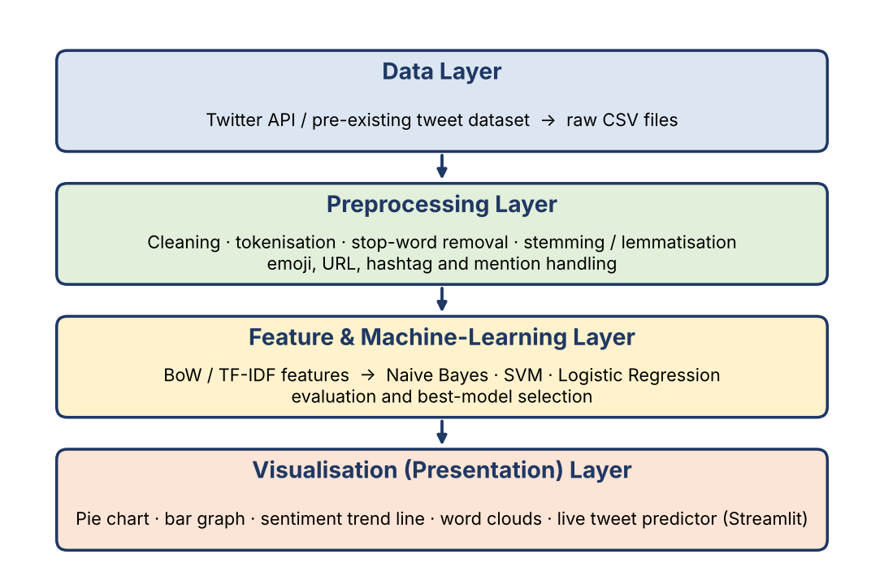
Fig. 4.1 High-level architecture of the sentiment-analysis system

4.2 Description of Each Layer

4.2.1 Data Layer
The data layer collects tweets on a chosen trending topic, hashtag or keyword, either through the Twitter (X) API or from a suitable pre-existing dataset. The tweets are stored unchanged in the raw-data folder so that the original source is always preserved.

4.2.2 Preprocessing Layer
The preprocessing layer turns noisy tweets into clean, normalised tokens. It converts text to lower case, removes URLs, handles mentions, hashtags, emojis and special characters, tokenises the text, removes stop words and applies stemming or lemmatisation. The output is a clean dataset stored in the processed-data folder.

4.2.3 Feature and Machine-Learning Layer
This layer first explores the data, then converts the clean text into Bag-of-Words and TF-IDF feature vectors. It trains Naive Bayes, SVM and Logistic Regression on the same stratified 80/20 split, evaluates each of them with accuracy, precision, recall, F1-score and the confusion matrix, and selects the best model. The selected model and the metrics table are saved for use by the dashboard.

4.2.4 Visualisation (Presentation) Layer
The visualisation layer reads the processed data, the saved model and the metrics. It offers three views: the Sentiment Overview, the Live Tweet Predictor and the Model Performance page. Users interact only with this layer and never need to run any code.

4.3 Deployment Architecture
The system is deployed in a simple local configuration suitable for an academic project: the Python environment, the processed data, the trained model and the Streamlit server all run on the same machine. The browser on that machine (or on the same network) acts as the client. For experimentation and demonstration, the notebooks can also be executed on Google Colab.
Table 4.1 Deployment configuration
Component | Where it runs
Data collection, preprocessing and modelling | Local machine (Jupyter) or Google Colab
Trained model and processed data | Project folder on local disk; code versioned in GitHub, data stored as files
Dashboard server | Streamlit server on the local machine, default port 8501
Client | Web browser
CI/CD | Not used in the current version; GitHub is used for version control only. Automated pipelines are listed as future work.

4.4 Data Flow Diagrams
A data-flow diagram (DFD) shows how data moves through a system without describing control flow. Fig. 4.2 shows the context-level (Level-0) DFD, in which the whole system is a single process that receives tweets and user inputs and returns charts, metrics and predicted sentiment labels.
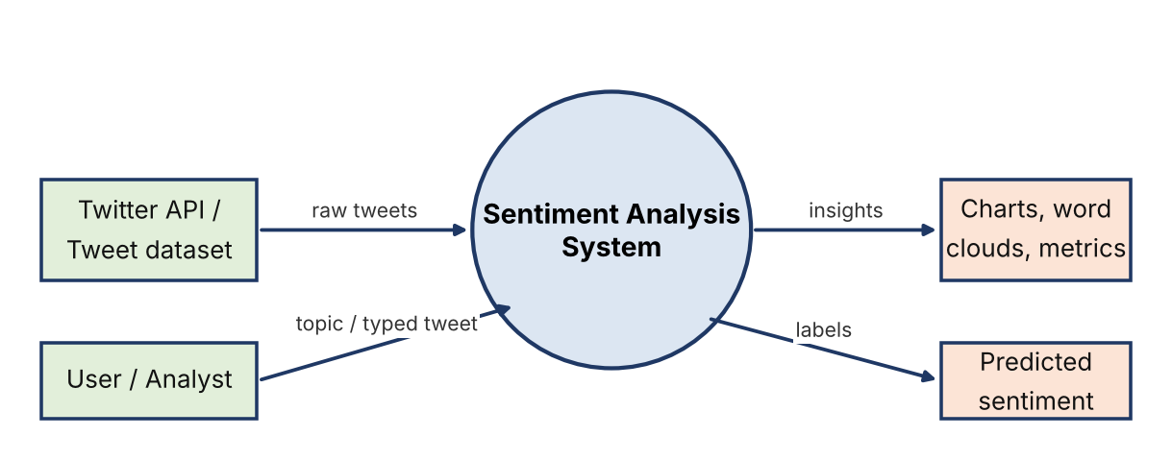
Fig. 4.2 DFD Level-0 (context diagram)
Fig. 4.3 expands the system into four processes – collection and preprocessing, feature extraction, model training and evaluation, and visualisation with prediction – and four data stores: raw tweets, clean tweets, feature matrix and trained model.
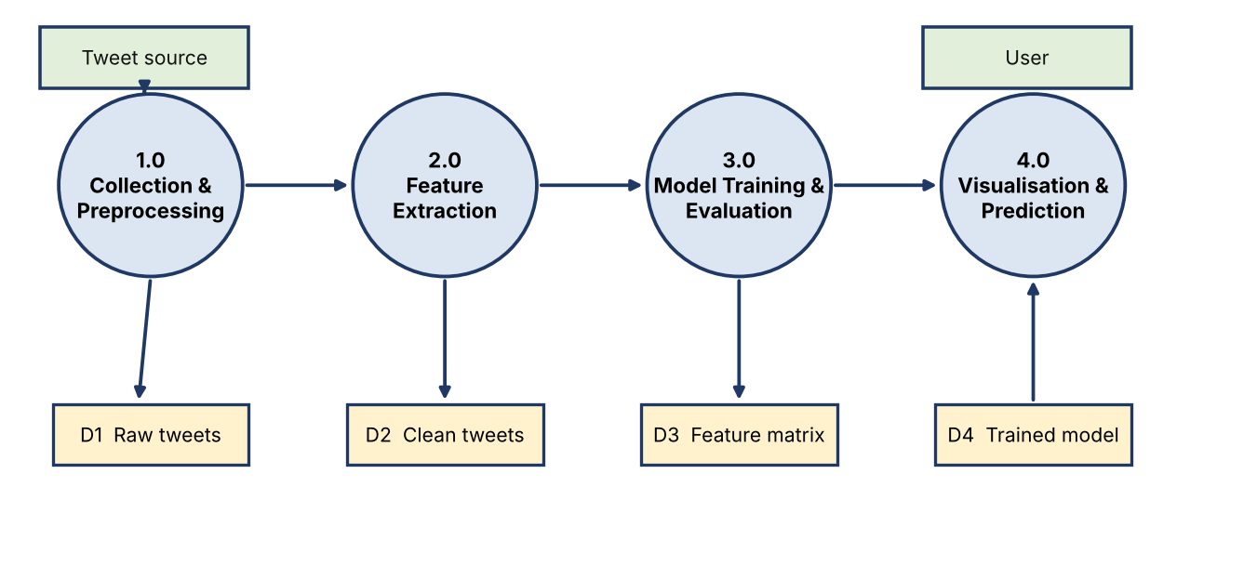
Fig. 4.3 DFD Level-1

CHAPTER 5
Design

5.1 Wireframes and Mock-ups
Before implementing the dashboard, simple wireframes were prepared for the three principal screens. They fix the position of filters, charts and result areas and make sure that every objective has a corresponding screen. The final screenshots of the implemented dashboard are given in Appendix A.

5.1.1 Sentiment Overview
The first screen summarises the sentiment of the collected tweets. A sidebar lets the user choose the topic or hashtag, date range, sentiment filter and model. The main area shows a pie chart of the sentiment share, a bar graph of tweet counts, a sentiment trend line over time and word clouds for the positive, negative and neutral categories.
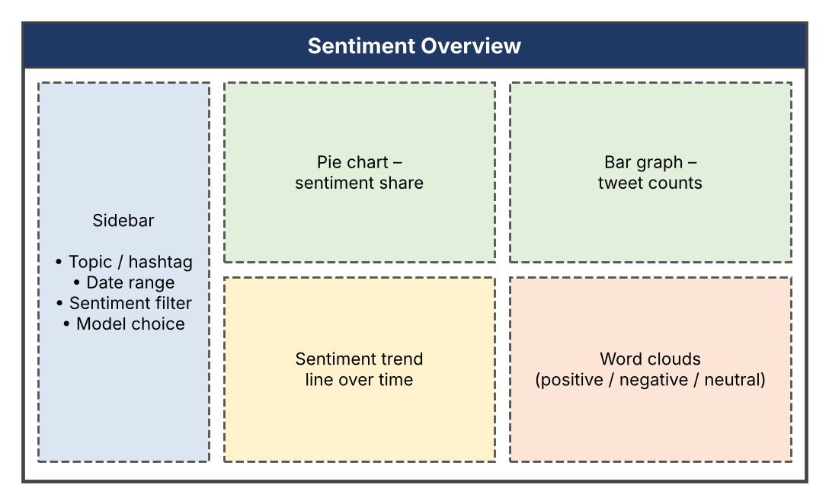
Fig. 5.1 Wireframe – Sentiment Overview

5.1.2 Live Tweet Predictor
The second screen accepts a typed or pasted tweet. On pressing the Predict Sentiment button, the saved model returns the predicted label and its probability, and the screen also shows the cleaned text so that the user can see how preprocessing changed the tweet.
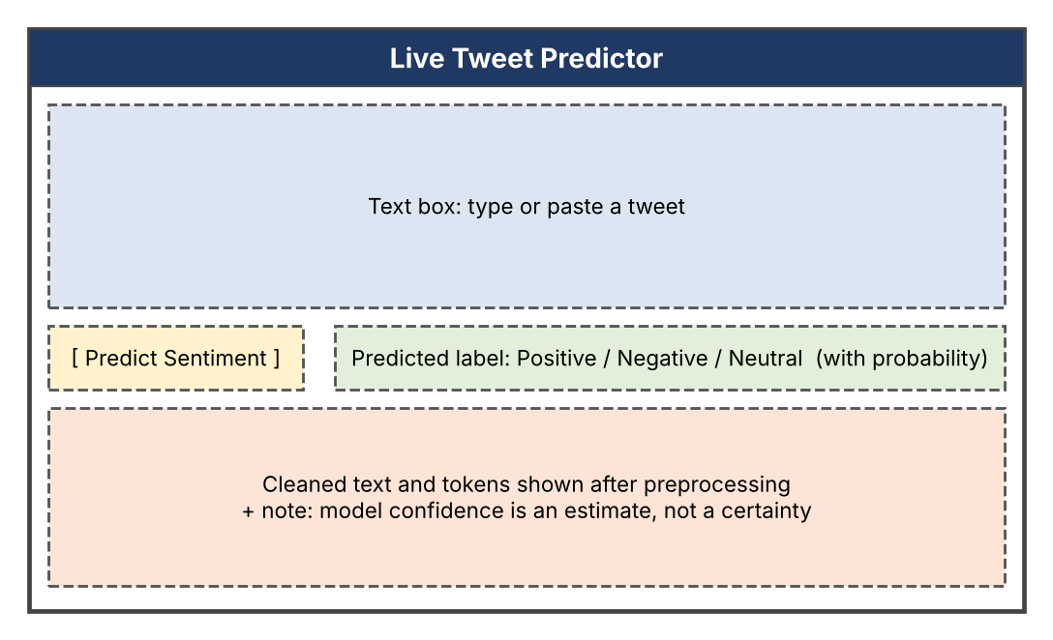
Fig. 5.2 Wireframe – Live Tweet Predictor

5.1.3 Model Performance
The third screen supports comparison of the models. It shows a bar chart of accuracy, precision, recall and F1-score, a metrics table and the confusion matrix of the selected model.
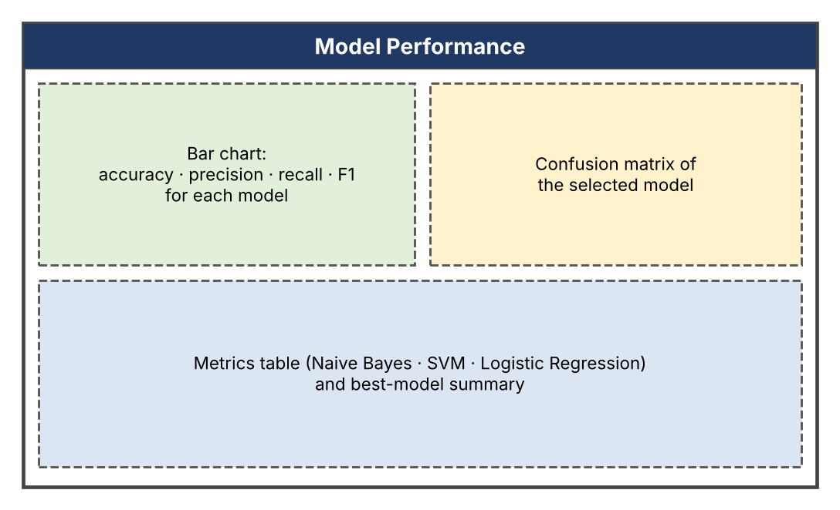
Fig. 5.3 Wireframe – Model Performance

5.2 ER Diagram / Database Schema
Although the current implementation stores data as files, a logical schema was designed so that the same structure can be moved to a relational database without change. Fig. 5.4 shows the five entities and the relationships among them.
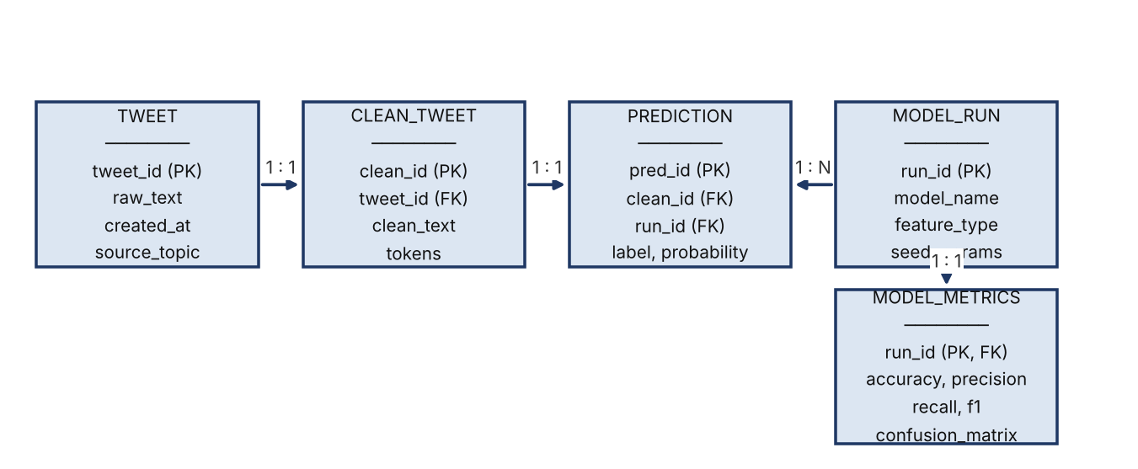
Fig. 5.4 Logical database schema (ER diagram)
Table 5.1 Description of schema entities
Entity | Description
TWEET | One row per collected tweet: identifier, raw text, timestamp and the topic or hashtag it was collected for. User names are not stored.
CLEAN_TWEET | The preprocessed version of a tweet: cleaned text and its token list; linked to TWEET through tweet_id.
PREDICTION | The sentiment label and probability assigned to a clean tweet by a particular model run.
MODEL_RUN | One row per training run: model name, feature type (Bag-of-Words or TF-IDF), random seed and parameters.
MODEL_METRICS | Accuracy, precision, recall, F1-score and confusion matrix produced by each model run (one-to-one with MODEL_RUN).

5.3 Pipeline Flowchart
Fig. 5.5 presents the sequence of operations executed by the processing and modelling layers. The same flow is repeated for each model and feature type so that the comparison is fair.
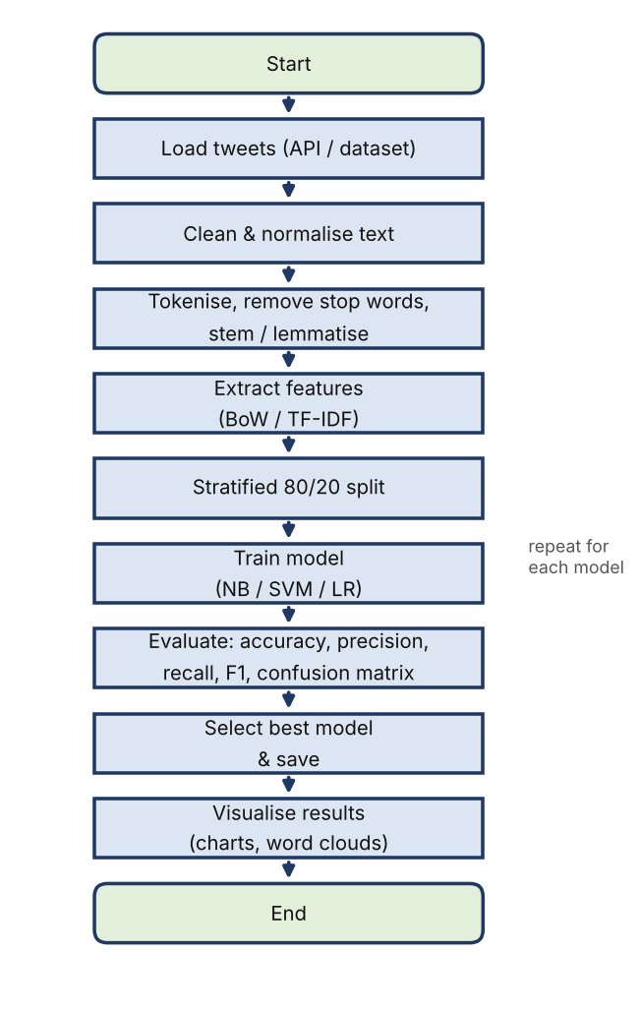
Fig. 5.5 Flowchart of the preprocessing and modelling pipeline

CHAPTER 6
Implementation

6.1 Module-wise Implementation
The project was divided into four modules. Each of the first three modules was developed primarily by one team member, and the fourth module was integrated jointly by the entire team. Every member understands and can explain every module.
Table 6.1 Modules of the system
Module | Purpose | Input → Output | Developed by
1. Data Collection & Preprocessing | Collect tweets and clean them | Raw tweets → clean tweets | V. Preetham Nikhil
2. Feature Extraction & EDA | Explore the data and build features | Clean tweets → feature matrix | K. Rishikesh Reddy
3. Model Training & Evaluation | Train and compare three classifiers | Features → metrics and best model | M. Sriram Madhav
4. Visualisation & Dashboard | Charts, word clouds and live prediction | Predictions + model → visuals | All team members

6.2 Data Collection and Preprocessing (Module 1)

6.2.1 Data sources
The system can work with tweets collected live through the Twitter (X) API or with a pre-existing labelled dataset. Candidate sources are listed in Table 6.2.
Table 6.2 Candidate data sources
Source | Content
Twitter (X) API | Live tweets for a chosen keyword, hashtag or trending topic, with timestamps; useful for trend lines. Access depends on the platform’s current rules and limits.
Sentiment140 | A large public dataset of about 1.6 million tweets labelled automatically from emoticons; the training file contains only positive and negative labels.
Twitter US Airline Sentiment | A public dataset of roughly 14,600 tweets about US airlines labelled positive, negative or neutral; suitable for three-class classification.

The dataset selected for the final experiments is summarised below.
Table 6.3 Summary of the selected dataset
Property | Value
Dataset name and source URL | [to be filled – dataset name / API topic and URL]
Number of tweets (rows) | [to be filled]
Number of columns | [to be filled]
Target variable | Sentiment label: positive, negative or neutral
Class distribution (pos / neg / neu) | [to be filled after class-balance check]

6.2.2 Preprocessing stages
Raw tweets are noisy, so a sequence of stages is applied before any analysis. Each stage is implemented as a function so that it can be tested separately.
- Lower-casing – all text is converted to lower case so that “Good” and “good” are treated as the same word.
- URL and mention handling – web links are removed, and user mentions (for example @name) are removed or replaced by a generic token, because they carry no sentiment and can identify users.
- Hashtag handling – the # symbol is removed and the word is kept, because hashtags such as #love or #disappointed often carry sentiment.
- Emoji handling – emojis are converted to descriptive words (for example a smiling face becomes “smiling_face”) so that their sentiment is not lost.
- Special characters and repeated letters – punctuation, digits and symbols are removed, and stretched words such as “soooo” are shortened.
- Tokenisation – the text is split into tokens using a tweet-aware tokeniser.
- Stop-word removal – common words are removed, but negation words such as “not” and “no” are kept because they reverse sentiment.
- Stemming and lemmatisation – words are reduced to their base form so that “loved”, “loving” and “loves” are treated alike.
import re, emoji, nltk
from nltk.corpus import stopwords
from nltk.stem import WordNetLemmatizer
from nltk.tokenize import TweetTokenizer

nltk.download("stopwords"); nltk.download("wordnet")

tok = TweetTokenizer(preserve_case=False, reduce_len=True)
lem = WordNetLemmatizer()
stop = set(stopwords.words("english")) - {"not", "no", "nor", "never"}

def clean_tweet(text):
text = emoji.demojize(text, delimiters=(" ", " ")) # emoji -> words
text = re.sub(r"http\S+|www\.\S+", " ", text) # URLs
text = re.sub(r"@\w+", " ", text) # mentions
text = re.sub(r"#", "", text) # keep hashtag word
text = re.sub(r"[^a-zA-Z_\s]", " ", text) # symbols, digits
tokens = [lem.lemmatize(t) for t in tok.tokenize(text)
if t not in stop and len(t) > 1]
return " ".join(tokens)

df = df.drop_duplicates(subset="text")
df["clean"] = df["text"].apply(clean_tweet)
df = df[df["clean"].str.len() > 0]

The same clean_tweet function is used during training and inside the dashboard, which guarantees that a tweet typed by the user is processed in exactly the same way as the training data.

6.3 Exploratory Data Analysis and Feature Extraction (Module 2)

6.3.1 Exploratory data analysis
Exploratory analysis was carried out to understand the data before modelling, and each analysis guides a modelling decision:
- Class distribution – a bar or pie chart shows whether positive, negative and neutral tweets are balanced; this decides whether a stratified split and F1-oriented evaluation are required.
- Tweet length and token counts – histograms show how long cleaned tweets are and whether very short tweets need special treatment.
- Most frequent words – frequency tables and word clouds for each sentiment class reveal the vocabulary that separates the classes.
- Sentiment over time – tweets grouped by hour or day show how sentiment changes as events unfold.

6.3.2 Feature extraction
Machine-learning models need numbers, not text, so each clean tweet is converted into a vector. Two feature representations are used and compared.
- Bag-of-Words (BoW) – each tweet is represented by the counts of the words (and word pairs) it contains. It is simple and fast but treats all words as equally important.
- TF-IDF – the count of a word in a tweet (term frequency) is multiplied by a factor that reduces the weight of words that appear in many tweets (inverse document frequency): tf-idf(t, d) = tf(t, d) × log(N / df(t)). Frequent but uninformative words therefore count for less, and distinctive words count for more.
Dense word embeddings are noted as a possible extension; they capture semantic relationships between words but need more data and tuning, so they are kept for future work. Unigrams and bigrams are used so that short phrases such as “not good” are captured.

6.4 Model Building and Evaluation (Module 3)

6.4.1 Algorithms used
Three classical classifiers were selected so that the study covers probabilistic, margin-based and linear approaches. Table 6.4 explains why each was chosen and the key parameters considered.
Table 6.4 Algorithms used in the project
Algorithm | Why chosen | Key parameters | Category
Naive Bayes (Multinomial) | Very fast and a standard baseline for text; works well with word counts and small data | alpha (smoothing) | Probabilistic
Support Vector Machine (Linear SVM) | Effective in high-dimensional sparse text features; often among the most accurate classical text classifiers | C (regularisation) | Margin-based
Logistic Regression | Interpretable baseline; coefficients show which words push a tweet towards each sentiment | C, solver, max_iter | Linear

Deep-learning models such as LSTM and BERT are heavier and depend on available computing resources, so in this version they are treated as planned extensions (Chapter 11) and the comparison is made among the three classical models.

6.4.2 Training set-up
- Features – Bag-of-Words and TF-IDF, with unigrams and bigrams.
- Data splitting – an 80/20 stratified train–test split, with 5-fold cross-validation on the training set for model comparison.
- Configuration – the same split and the same random seed are used for every model and feature type so that the comparison is fair.
- Metrics – because there are three classes, precision, recall and F1-score are macro-averaged (each class counts equally), alongside accuracy.
from sklearn.model_selection import train_test_split, cross_val_score
from sklearn.feature_extraction.text import CountVectorizer, TfidfVectorizer
from sklearn.naive_bayes import MultinomialNB
from sklearn.svm import LinearSVC
from sklearn.linear_model import LogisticRegression
from sklearn.pipeline import Pipeline
from sklearn.metrics import classification_report, confusion_matrix

X, y = df["clean"], df["sentiment"]
X_train, X_test, y_train, y_test = train_test_split(
X, y, test_size=0.20, stratify=y, random_state=42)

features = {"BoW": CountVectorizer(ngram_range=(1, 2), min_df=2),
"TF-IDF": TfidfVectorizer(ngram_range=(1, 2), min_df=2)}
models = {"NaiveBayes": MultinomialNB(),
"SVM": LinearSVC(C=1.0),
"LogReg": LogisticRegression(max_iter=1000)}

results = []
for fname, vec in features.items():
for mname, clf in models.items():
pipe = Pipeline([("vec", vec), ("clf", clf)])
cv = cross_val_score(pipe, X_train, y_train, cv=5, scoring="f1_macro")
pipe.fit(X_train, y_train)
pred = pipe.predict(X_test)
print(fname, mname, "CV macro-F1 =", cv.mean().round(3))
print(classification_report(y_test, pred))
print(confusion_matrix(y_test, pred))
results.append({"features": fname, "model": mname, "pipeline": pipe})

6.4.3 Selection of the final model
The final model is selected using the best macro-averaged F1-score on the test data, balanced with interpretability and speed. Macro-averaging is used so that a model cannot score well simply by predicting the largest class. The selected pipeline (vectoriser plus classifier) is saved with Joblib so that the dashboard can load it.

6.5 Visualisation and Dashboard Logic (Module 4)
The classified tweets are presented through four standard visualisations: a pie chart of the overall sentiment share, a bar graph of tweet counts per sentiment, a sentiment trend line that shows how the share of each sentiment changes over time, and word clouds that highlight the most frequent terms in each sentiment category. These are brought together in a single Streamlit dashboard organised into three pages selected from a sidebar. Streamlit re-runs the script whenever a widget value changes, and the data and model are cached so that the dashboard stays responsive.
import streamlit as st, pandas as pd, joblib, plotly.express as px
from wordcloud import WordCloud
import matplotlib.pyplot as plt

@st.cache_data
def load_data(): return pd.read_csv("data/processed/predictions.csv", parse_dates=["created_at"])
@st.cache_resource
def load_model(): return joblib.load("models/best_model.joblib")

page = st.sidebar.radio("Page", ["Overview", "Live Predictor", "Model Performance"])
df, model = load_data(), load_model()

if page == "Overview":
st.plotly_chart(px.pie(df, names="sentiment", title="Sentiment share"))
st.plotly_chart(px.bar(df["sentiment"].value_counts().reset_index(),
x="sentiment", y="count", title="Tweet counts"))
trend = (df.set_index("created_at").groupby("sentiment")
.resample("D").size().reset_index(name="tweets"))
st.plotly_chart(px.line(trend, x="created_at", y="tweets", color="sentiment"))
label = st.selectbox("Word cloud for", ["positive", "negative", "neutral"])
text = " ".join(df.loc[df["sentiment"] == label, "clean"])
fig, ax = plt.subplots(); ax.axis("off")
ax.imshow(WordCloud(width=800, height=400).generate(text)); st.pyplot(fig)

elif page == "Live Predictor":
tweet = st.text_area("Type or paste a tweet")
if st.button("Predict Sentiment") and tweet.strip():
st.success("Predicted sentiment: " + model.predict([clean_tweet(tweet)])[0])

The code above is shown in simplified form to explain the structure of the dashboard; the complete script additionally handles the date and sentiment filters, the probability display and the Model Performance page.

6.6 Data Connectivity and API Integration
When live data is required, tweets are collected through the Twitter (X) API during the data-collection stage, using a search query built from the chosen keyword or hashtag. Collection respects the platform’s rate limits, and the results are saved as a CSV file so that all later stages work on a fixed copy of the data. The dashboard itself connects only to stored files – the processed dataset, the trained model and the metrics table – through simple file reads, so no external service is called at run time and the dashboard keeps working without network access.

6.7 Access Control, Authentication and Data Privacy
The current version is intended for local use by the project team, examiners and invited users, and therefore does not implement user accounts. Privacy is protected by design: only public tweets are analysed, user names and mentions are removed during preprocessing, and text typed on the Live Predictor page is processed in memory and not stored. API keys and tokens are kept in environment variables and never written into notebooks or committed to GitHub. Collection and use of tweets follow the platform’s developer terms. Role-based access is included in the future scope.

CHAPTER 7
Features

7.1 List of Main Features
- Collection of tweets for a chosen topic, hashtag or keyword through the Twitter (X) API or from a dataset.
- Tweet-aware preprocessing that handles hashtags, mentions, emojis, special characters and URLs.
- Bag-of-Words and TF-IDF feature extraction with unigrams and bigrams.
- Training and comparison of Naive Bayes, SVM and Logistic Regression on identical data splits.
- Evaluation using accuracy, precision, recall, F1-score and confusion matrix.
- Sentiment Overview with pie chart, bar graph, trend line over time and word clouds.
- Live Tweet Predictor that returns positive, negative or neutral for any typed tweet.
- Model Performance page for side-by-side comparison of all models.

7.2 How Each Feature Works
Table 7.1 Feature descriptions – user perspective and technical description
Feature | User perspective | Technical description
Tweet collection | The user chooses a topic or hashtag, or places a dataset in the data folder, and runs the pipeline. | A search query is sent to the Twitter (X) API (or a CSV is read with Pandas) and the tweets are saved to the raw-data folder.
Preprocessing | No manual effort; clean text is produced automatically. | The clean_tweet function applies regex rules, emoji conversion, tokenisation, stop-word removal and lemmatisation.
Feature extraction | Invisible to the user. | CountVectorizer and TfidfVectorizer build sparse matrices of unigram and bigram features.
Model comparison | A table and chart show which model performs best. | Six pipelines (3 models × 2 feature types) are trained with the same seed and split; classification_report and confusion_matrix are computed.
Sentiment Overview | The user selects a topic, date range or sentiment and instantly sees the charts. | Streamlit widgets filter the DataFrame; Plotly renders pie, bar and line charts, and WordCloud renders the clouds.
Live Tweet Predictor | The user types a tweet and presses Predict Sentiment to see the label. | The text is cleaned with clean_tweet and passed through the saved pipeline; the predicted label is displayed.
Model Performance page | The user sees all metrics and the confusion matrix of the best model. | Metrics saved after training are read from file and plotted.

CHAPTER 8
Testing
Testing was carried out at three levels: functional testing of each pipeline stage, integration testing of the complete flow from raw tweets to dashboard, and performance testing of the machine-learning models. Postman testing, which applies to web back-ends, is not applicable because the system exposes no REST API; the equivalent activity here is the validation of dashboard inputs and outputs described in Section 8.1.

8.1 Functional Testing (Pipeline and Dashboard)
Each stage of the pipeline was tested using small sample files with known characteristics. For example, a set of tweets containing URLs, mentions, hashtags, emojis and repeated letters was passed through the cleaning function and the output was checked against the expected result. On the dashboard, valid, empty and very long inputs were entered on the Live Predictor page to confirm that it either returns a valid label or shows a clear message.

8.2 Integration Testing
Integration testing confirmed that the modules cooperate correctly: the clean dataset from Module 1 is accepted by Module 2, the feature pipeline from Module 2 is accepted by Module 3, and the model saved by Module 3 is loaded and used by Module 4. The complete flow was executed end to end on a fresh environment to verify that no step depends on variables left over in a notebook session.

8.3 Tools Used for Testing
- Jupyter / Google Colab – interactive execution and inspection of intermediate outputs.
- Pandas assertions – checks that no empty or duplicate tweets remain after cleaning.
- Scikit-learn metrics and cross-validation – accuracy, precision, recall, F1-score, confusion matrix and k-fold validation.
- Streamlit – manual testing of widgets and displayed output in the browser.

8.4 Test Cases and Results
Table 8.1 lists the representative test cases. The “Actual result” and “Status” columns are to be recorded after the final execution on the selected dataset.
Table 8.1 Test cases
Test ID | Test description | Expected result | Actual result | Status
TC-01 | Tweet collection / dataset loading | Tweets load with the expected columns | [Record result] | [Pass / Fail]
TC-02 | URL, mention, hashtag and emoji handling | URLs and mentions removed; hashtag words and emoji meanings kept | [Record result] | [Pass / Fail]
TC-03 | Stop-word removal with negation | Common words removed; “not” and “no” retained | [Record result] | [Pass / Fail]
TC-04 | Training of all three models on both feature types | Each of the six pipelines trains and predicts | [Record result] | [Pass / Fail]
TC-05 | Live prediction on a clearly positive / negative tweet | Correct label displayed | [Record result] | [Pass / Fail]
TC-06 | Empty or whitespace-only input | Clear message, no crash | [Record result] | [Pass / Fail]
TC-07 | Dashboard filters (date, sentiment) | Charts update for every filter choice | [Record result] | [Pass / Fail]

8.5 Validation Method and Evaluation Framework
Validation uses an 80/20 stratified train–test split together with 5-fold cross-validation on the training data for every model. The metrics are defined below, where TP, TN, FP and FN denote true positives, true negatives, false positives and false negatives for a given sentiment class. For the three-class problem each metric is calculated per class and then macro-averaged.
Table 8.2 Evaluation metrics
Metric | Formula | Meaning in this project
Accuracy | (TP + TN) / (TP + TN + FP + FN) | Share of all tweets whose sentiment is predicted correctly
Precision | TP / (TP + FP) | Of the tweets predicted as a sentiment, the share that truly have it
Recall | TP / (TP + FN) | Of the tweets that truly have a sentiment, the share that are found
F1-score | 2 × Precision × Recall / (Precision + Recall) | Balance between precision and recall
Confusion matrix | 3 × 3 table of actual vs predicted classes | Shows exactly which sentiments are confused with which

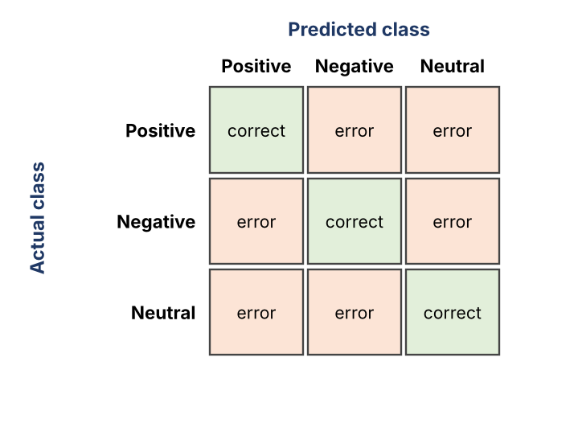
Fig. 8.1 Layout of the confusion matrix used for evaluation

8.6 Results and Performance Comparison
Table 8.3 compares the models on the held-out test set with both feature types. The best model is the one with the highest macro-averaged F1-score.
Table 8.3 Performance comparison of the models
Model | Features | Accuracy | Precision | Recall | F1-score
Naive Bayes | Bag-of-Words | [ ] | [ ] | [ ] | [ ]
Naive Bayes | TF-IDF | [ ] | [ ] | [ ] | [ ]
SVM | Bag-of-Words | [ ] | [ ] | [ ] | [ ]
SVM | TF-IDF | [ ] | [ ] | [ ] | [ ]
Logistic Regression | Bag-of-Words | [ ] | [ ] | [ ] | [ ]
Logistic Regression | TF-IDF | [ ] | [ ] | [ ] | [ ]

Best model: [model name + feature type] with a macro-averaged F1-score of [XX.X%].

8.6.1 Interpretation of results
- Precision versus recall – comparing the two shows whether a model produces more wrongly labelled tweets or more missed ones for a given sentiment.
- Neutral class – neutral tweets are usually the hardest to classify because they sit between the two polarities; the confusion matrix shows how many are pushed into positive or negative.
- BoW versus TF-IDF – the comparison shows whether down-weighting very common words improves each model.
- Key words – the highest-weighted words of Logistic Regression and the word clouds show which terms drive each sentiment.
[Insert the confusion matrix of the best model here]

CHAPTER 9
Deployment

9.1 Steps to Deploy
The following steps install and run the system on a new Windows machine.
- Install Python 3 and Git from their official websites.
- Clone the project repository from GitHub: git clone <repository-URL> and open the project folder.
- Create and activate a virtual environment: python -m venv venv followed by venv\Scripts\activate.
- Install the dependencies: pip install -r requirements.txt and download the NLTK data (stop words and WordNet).
- Place the dataset in the data/raw folder, or set the API credentials as environment variables for live collection.
- Run the pipeline notebooks (or script) in order: preprocessing → features and EDA → modelling. This creates the processed data, the saved model and the metrics file.
- Start the dashboard: streamlit run app.py.
- Open the displayed local address (by default http://localhost:8501) in a web browser.

9.2 Environment Configuration
Table 9.1 Environment configuration
Item | Configuration
Python version | Python 3.x (recorded in requirements.txt / README)
Dependencies | pandas, numpy, nltk, emoji, scikit-learn, matplotlib, seaborn, wordcloud, plotly, streamlit, joblib – installed from requirements.txt
Random seed | random_state = 42 for all splits and models
Secrets | API keys and tokens stored in environment variables, never in the code or the repository
Folder structure | data/raw, data/processed, models, notebooks, app.py
Port | Streamlit default 8501 (configurable with --server.port)

9.3 Hosting
In the current version the dashboard is hosted locally: the Streamlit server runs on the developer’s machine and is accessed through the browser. The notebooks may also be executed on Google Colab. Because the dashboard is a standard Streamlit application, it can later be hosted on a public platform such as Streamlit Community Cloud or a cloud virtual machine without code changes; this is part of the future scope.

CHAPTER 10
Challenges & Limitations

10.1 Issues Faced During Development
- Noisy, informal text – slang, abbreviations, spelling variations, hashtags, mentions, emojis and URLs made raw tweets hard to analyse directly.
- Negation and context – removing stop words naively would delete words such as “not” that flip the meaning of a sentence.
- Imbalanced classes – one sentiment (often negative or neutral) can be much more frequent than the others, which makes plain accuracy misleading.
- Sarcasm and mixed sentiment – statements that say the opposite of what they mean are hard for bag-of-words models.
- API access and rate limits – live collection is restricted by the platform’s access rules, so the amount of live data is limited.
- Team coordination – three members developed different modules at the same time and had to merge their work without conflicts.

10.2 Solutions Applied
Table 10.1 Challenges and solutions
Challenge | Solution applied
Noisy, informal text | Documented preprocessing stage: URL/mention removal, hashtag and emoji conversion, repeated-letter reduction, lemmatisation
Negation | Negation words kept in the stop-word list exception; bigram features capture phrases such as “not good”
Imbalanced classes | Stratified split; macro-averaged F1-score and recall used as primary metrics
Sarcasm | Acknowledged as a limitation; deep contextual models listed as future work
API limits | Collected tweets saved to CSV and a pre-existing labelled dataset used for training
Team coordination | GitHub branches per module, regular merges and shared documentation

10.3 Current Limitations or Known Bugs
- Tweets collected for one topic and period may not represent the whole population; users who tweet are not a random sample of the public.
- Labels in some public datasets are produced automatically (for example from emoticons) and may contain errors.
- Sarcasm, irony and mixed emotions are often misclassified by the classical models used.
- Only English tweets are handled; multilingual and code-mixed tweets are out of scope.
- Only classical machine-learning models are used; LSTM and BERT are future work.
- The dashboard has no user authentication or role-based access in the current version.

CHAPTER 11
Future Enhancements

11.1 Planned Features
Table 11.1 Planned enhancements
Area | Planned enhancement
Improve accuracy | Fine-tune LSTM networks and transformer-based models such as BERT, and use dense word embeddings; add hyper-parameter tuning (grid or random search).
Handle harder language | Detect sarcasm and mixed sentiment; support Hindi, Telugu and code-mixed tweets.
Real-time operation | Continuous streaming of tweets with live-updating charts and automatic alerts when negative sentiment spikes.
Deeper analysis | Aspect-based sentiment (what exactly people like or dislike) and emotion categories beyond positive/negative/neutral.
Deploy and secure | Public web dashboard on a cloud platform with role-based access and stronger privacy controls.

11.2 Possible Integrations and Optimisations
- PostgreSQL for persistent storage of large tweet collections, with caching of frequent dashboard queries.
- Explainable AI techniques such as LIME or SHAP to show which words led to each prediction.
- Power BI integration as an alternative reporting front-end for managers.
- Automated pipelines (CI/CD) to retrain and re-evaluate models whenever new tweets are added.

11.3 Real-World Applications
- Brand monitoring and reputation management.
- Political sentiment and election analysis.
- Market research and consumer-behaviour studies.
- Customer-feedback analysis.
- Crisis and disaster-response management, where understanding public mood in real time supports faster decisions.

CHAPTER 12
Conclusion

12.1 Summary of the Project
Sentiment Analysis of Tweets is an end-to-end system built in Python that collects tweets on a chosen trending topic, cleans and normalises them, converts them into Bag-of-Words and TF-IDF features, and classifies each tweet as positive, negative or neutral using Naive Bayes, Support Vector Machine and Logistic Regression. The models are trained on identical data and compared on accuracy, precision, recall, F1-score and confusion matrix. The results are presented through pie charts, bar graphs, sentiment trend lines and word clouds in an interactive Streamlit dashboard, turning raw, unstructured text into structured, actionable insight.

12.2 What Was Achieved
Table 12.1 Objectives and outcomes
No. | Objective | Outcome
1 | Collect and prepare tweet data with a full preprocessing pipeline | Achieved – tweet-aware cleaning of hashtags, mentions, emojis, special characters and URLs, with tokenisation, stop-word removal and lemmatisation
2 | Extract Bag-of-Words and TF-IDF features | Achieved – unigram and bigram features built with both methods
3 | Train and compare Naive Bayes, SVM and Logistic Regression | Achieved – six pipelines trained on the same split and seed
4 | Evaluate every model with five measures | Achieved – accuracy, precision, recall, F1-score and confusion matrix computed
5 | Visualise the results | Achieved – pie chart, bar graph, trend line and word clouds in the dashboard

All five objectives were addressed. The final outcome is a single pipeline in which the models are compared fairly and the sentiment of a topic can be read at a glance. Final accuracy figures are reported in Table 8.3.

12.3 Skills Learned During Development
- Collecting and cleaning real-world, noisy text data.
- Applying NLP techniques: tokenisation, stop-word handling, stemming, lemmatisation and feature extraction with Bag-of-Words and TF-IDF.
- Implementing and comparing machine-learning classifiers with Scikit-learn and interpreting precision, recall, F1-score and confusion matrices on multi-class data.
- Building interactive visualisations and dashboards with Plotly, WordCloud and Streamlit.
- Collaboration with Git and GitHub, modular design and technical documentation, along with awareness of privacy and ethical aspects of social-media analysis.

CHAPTER 13
References
[1] B. Pang, L. Lee and S. Vaithyanathan, “Thumbs up? Sentiment classification using machine learning techniques,” in Proc. Conf. Empirical Methods in Natural Language Processing (EMNLP), 2002, pp. 79–86.
[2] A. Go, R. Bhayani and L. Huang, “Twitter sentiment classification using distant supervision,” CS224N Project Report, Stanford University, 2009.
[3] E. Kouloumpis, T. Wilson and J. Moore, “Twitter sentiment analysis: The good the bad and the OMG!,” in Proc. 5th Int. AAAI Conf. Weblogs and Social Media (ICWSM), 2011.
[4] J. Devlin, M.-W. Chang, K. Lee and K. Toutanova, “BERT: Pre-training of deep bidirectional transformers for language understanding,” in Proc. NAACL-HLT, 2019.
[5] S. Hochreiter and J. Schmidhuber, “Long short-term memory,” Neural Computation, vol. 9, no. 8, pp. 1735–1780, 1997.
[6] G. Salton and C. Buckley, “Term-weighting approaches in automatic text retrieval,” Information Processing & Management, vol. 24, no. 5, pp. 513–523, 1988.
[7] S. Bird, E. Klein and E. Loper, Natural Language Processing with Python. O’Reilly Media, 2009.
[8] F. Pedregosa et al., “Scikit-learn: Machine learning in Python,” J. Mach. Learn. Res., vol. 12, pp. 2825–2830, 2011.
[9] W. McKinney, “Data structures for statistical computing in Python,” in Proc. 9th Python in Science Conf., 2010, pp. 56–61.
[10] Streamlit Inc., “Streamlit documentation,” [Online]. Available: https://docs.streamlit.io
[11] Plotly Technologies Inc., “Plotly Python graphing library,” [Online]. Available: https://plotly.com/python/

CHAPTER 14
Appendices

Appendix A – Screenshots of the Application
The screenshots below show the implemented dashboard. Each screenshot should be captioned with what the viewer should notice.
[Paste screenshot: Sentiment Overview]

Fig. A.1 Sentiment Overview – pie chart, bar graph, trend line and word clouds for the chosen topic.
[Paste screenshot: Live Tweet Predictor]

Fig. A.2 Live Tweet Predictor – type a tweet to obtain its predicted sentiment.
[Paste screenshot: Model Performance]

Fig. A.3 Model Performance – compare accuracy, precision, recall, F1-score and confusion matrix.

Appendix B – Sample Code Snippets
The key code segments are presented in Chapter 6 (preprocessing function, model training and the dashboard script). The following snippet shows how the best model is saved and reloaded.
import joblib

best = max(results, key=lambda r: r["macro_f1"]) # highest macro-F1
joblib.dump(best["pipeline"], "models/best_model.joblib")

model = joblib.load("models/best_model.joblib") # in the dashboard
model.predict([clean_tweet("The launch event was absolutely brilliant!")])

Appendix C – Installation and Set-up Instructions
- Install Python 3 (python.org) and Git (git-scm.com).
- Run git clone <repository-URL> and change into the project folder.
- Run python -m venv venv and activate it with venv\Scripts\activate (Windows) or source venv/bin/activate (Linux/macOS).
- Run pip install -r requirements.txt and download the NLTK stop-word and WordNet data.
- Copy the dataset into data/raw/ (or set the API credentials as environment variables).
- Execute the notebooks in the order 01_preprocessing, 02_features_eda, 03_modelling.
- Run streamlit run app.py and open http://localhost:8501.

Appendix D – User Manual
- Open the dashboard in a web browser and choose a page from the left sidebar.
- Overview: choose the topic, date range or sentiment; the pie chart, bar graph, trend line and word clouds update automatically. Hover over a chart for exact values.
- Live Predictor: type or paste a tweet, press Predict Sentiment and read the predicted label. Remember that the model gives an estimate, not a certainty.
- Model Performance: review the metrics table and the confusion matrix to see how each model performed.

Appendix E – Certifications
[Attach course / workshop certificates of the team members, if any]

Appendix F – Team Contribution
Table F.1 Contribution of each team member
Reg. No. | Name | Contribution / modules handled
2420030302 | V. Preetham Nikhil | Data collection and preprocessing module; data and methodology report sections
2420030318 | K. Rishikesh Reddy | Feature extraction and EDA module; visualisations and report sections
2420030273 | M. Sriram Madhav | Model training and evaluation module; dashboard integration and results

Project links: GitHub – [URL] | Dataset – [URL] | Demo video – [URL]

